* Full name: Iván Kaleb Ramírez Torres
* NAO ID: 3357
* Date: September 8th, 2025
* Name of the pathway in which you are enrolled: Bécalos Teho Ready
* Title of the Challenge: **Develop – GitHub 1**

## Table of Contents

|  |  |
| --- | --- |
| Screenshot | Content |
| 1 | GitHub account creation |
| 2 | Git installation on my computer |
| 3 | SSH key generation |
| 4 | SSH key configuration |
| 5 | GitHub configuration in Git terminal |

## Screenshots

### GitHub account creation

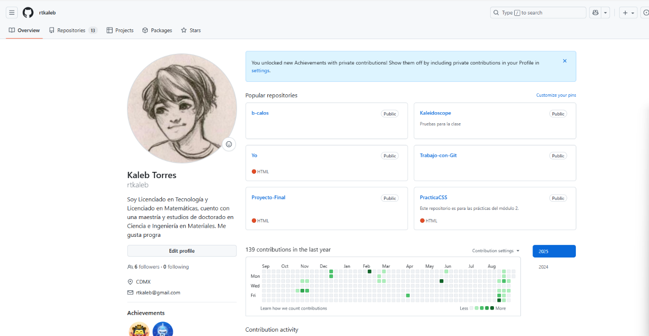

Here I have an screenshot of my GitHub repository “rtkaleb” I have made.  
As I already have an account, I already have projects in my online repository.

### Git installation on my computer

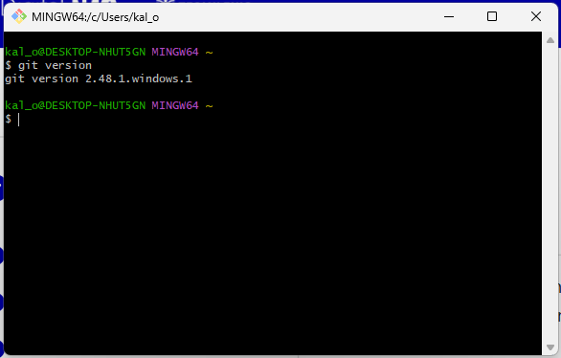

I have a screenshot of my git version from my git bash. I case of not having git instaled, I wouldn’t be able to have the git bash in the first place and being able to request the git version in terminal.

SSH key generation 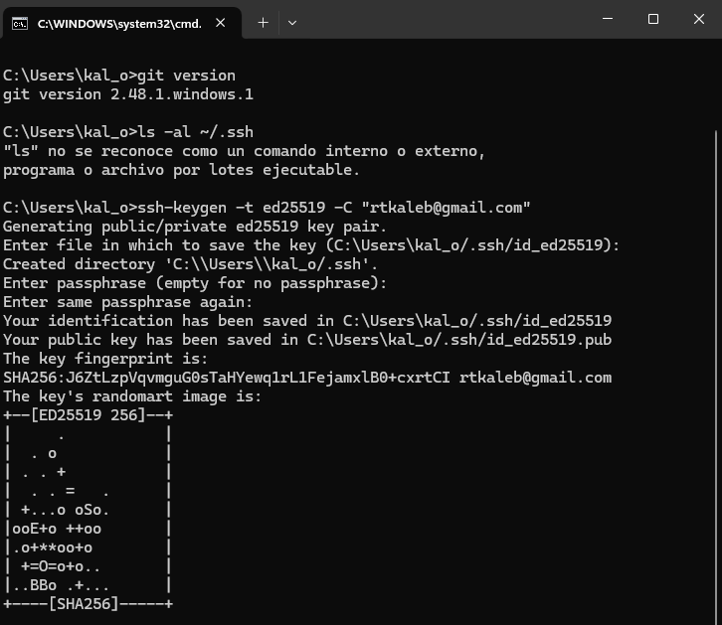

Here I have the screenshot of commands for generation of SSH key in my computer terminal.

Commands used were:  
  
1. ssh-keygen -t ed25519 -C "rtkaleb@gmail.com"

For generating the key in RSA safe algorithm.  
Then the console gave opportunity to choose the file to save it and the option to generate a password for access to the key in case other personas use the same computer.

I choose the suggesting carpet and to write a password.

2. eval "$(ssh-agent -s)"

ssh-add ~/.ssh/id_ed25519

Commands used to add the key to the agent SSH.

Then, I added the key in my GitHub repository that I created in the first step by adding from configuration /SSH and GPG Keys/SSH Keys by copypasting the key from my terminal in description from GitHub.

At last, I configured my GitHub account into my Git terminal with command:  
  
ssh -T git@github.com

Resulting in the image of this final screenshot.